HOW TO CALCULATE BEARING CAPACITY OF SOIL FROM PLATE LOAD TEST?

PLT (PLATE LOAD TEST)
Plate load test is a field test which is commonly adopted to determine the bearing capacity and settlement of soil under a given condition of loading.
In this test a square or circular rigid plate of standard dimension (generally 300 mm2 for square or 300 mm dia for circular) is placed at foundation level and load is applied in increments. Then settlement of the plate corresponding to each load increment is recorded for calculating bearing capacity of soil.
To know the detail test procedure click the link given below.
How to perform Plate Load Test On site?

CALCULATION OF BEARING CAPACITY OF SOIL
The whole process of calculating bearing capacity of soil using plate load test data consists of the following 4 primary steps.
- Step-1 (Plotting a Load-Settlement Curve)
- Step-2 (Finding Ultimate Bearing Capacity)
- Step-3 (Calculating Safe Bearing Capacity)
- Step-4 (Calculating Settlement of Proposed Footing)

1. STEP-1 (PLOTTING A LOAD-SETTLEMENT CURVE)
After performing the plate load test, plot a load settlement curve (see fig-1) on arithmetic scale, with applied pressure in kN/m² in x-axis and corresponding settlement (in mm) in y-axis.
Depending on the type of soil below the test plate, the load settlement curve can be of 4 different types as shown below.
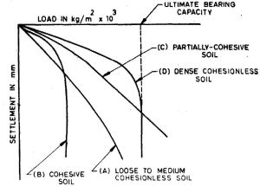Fig-1 Types of load settlement curves
Curve A: This type curve is obtained in case of loose to medium cohesion less soil (i.e. 15 < N < 30). This type of curve shows no clear point of failure.
Curve B: This type curve is obtained in case ofcohesive soil. As the load increases the curve leans toward settlement curve.
Curve C: This type curve is obtained in case ofpartially cohesive soil (i.e. C-phi soil). This type of curve also does not show a clear point of failure.
Curve D: This type curve is obtained in case of dense cohesionless soil (i.e. N > 30). This type of curve is common in case of dense sand or gravel deposits.

2. STEP-2 (FINDING ULTIMATE BEARING CAPACITY)
After drawing the load settlement curve, the next step is to identify the failure point on the load settlement curve.
In case of curve B & D, the point of failure can be easily identified by the sudden drop down of the curve. Or draw two tangent lines from the beginning straight portion of the curve and end straight portion of the curve. The point where these two tangents cross each other is called the point of failure. The pressure corresponding to this point is called ultimate bearing capacity of the soil.
But in case of curve A & C, it is difficult to find out a clear point of failure on the load settlement curve. To overcome this problem scientist Abbet introduced another method of drawing load settlement curve. According to his method, a log-log chart is plotted with settlement are plotted as abscissa against corresponding pressure intensities as ordinate. Such a plotting will give two straight lines, the intersection of which will be considered as the failure point. Find the corresponding value of pressure to the failure point. This is considered as the ultimate bearing capacity of soil.
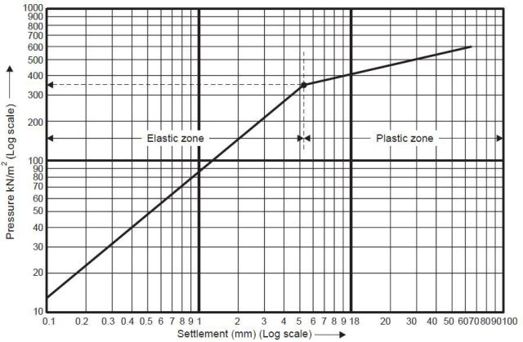log-log scale

3. STEP-3 (CALCULATING SAFE BEARING CAPACITY)
In order to calculate safe bearing capacity of the soil, divide the ultimate bearing capacity of soil by a suitable factor of safety.
Safe bearing capacity of soil = Ultimate bearing capacity / Factor of safety
The values of factor of safety normally used are 2, 2.5 or 3 depending upon the site condition and importance of the structure.

4. STEP-4 (CALCULATING SETTLEMENT OF PROPOSED FOOTING)
The following formula as suggested by Terzaghi and Peck is used to calculate the settlement of footing for granular soil.
S_{f} = S_{p} {[B*(B_{p}+0.3)] / [B_{p}*(B+0.3)]}²
For clayey soil the following equation can be used.
S_{f} = S_{p}*(B/B_{p})
Where,
S_{p} = Settlement of plate, mm
S_{f} = Settlemnt of footing, mm
B_{p} = Width or dia of plate, m
B = Width of footing, m
For calculating settlement of a given size of foundation subjecting to a given load, first calculate the corresponding intensity of loading by dividing the area of footing by the load, i.e.
Intensity of Loading = Load (kN) / Area of footing (m²)
Then from the load settlement curve drawn using PLT data, find out the plate settlement corresponding to the calculated intensity of loading and use this value of settlement in the formula to calculate the settlement of footing.

EXAMPLE CALCULATION
A plate load test was conducted using a plate of 0.75m*0.75m size, on a uniform deposit of sand and the following data were obtained:
Pressure (KN/m²) | Settlement (mm)
0 | 0
50 | 1.5
100 | 2
200 | 4
300 | 7.5
400 | 12.5
500 | 20
600 | 40.6
Calculate the safe bearing capacity of soil taking factor of safety as 2.5.
Calculate settlement of a square footing of size 2mx2m at safe bearing capacity

ANSWER
Calculation of Safe Bearing Capacity
From the load settlement curve (see fig below) the ultimate bearing capacity of soil is found to be 500 kN/m² and corresponding settlement is 12 mm.
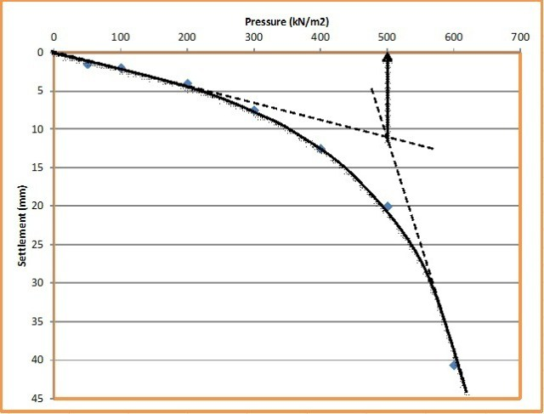Load settlement curve
So Safe bearing capacity (q_{safe}) = Ultimate bearing capacity (q_{ult}) / Factor of safety = 500 / 2.5 = 200 kN/m²
Calculation of Footing Settlement
Width of footing (B) = 2m
Width of plate (B_{p}) = 750 mm = 0.75m
Plate settlement (S_{p}) = 12mm
So settlement of footing at safe load can be calculated using the following formula
S_{f} = S_{p} {[B*(B_{p}+0.3)] / [B_{p}*(B+0.3)]}²
S_{f} = 12 {[2*(0.75+0.3)] / [0.75*(2+0.3)]}²
S_{f} = 17.78 = 18 mm

